Reading 4 – Marks and channels
Visualization

TopicS
- Marks and Channels

Reading(s)

required
Munzner: Chapter 5. (yes, we skipped chapter 4 on Validation)

recommended
Links to topics related to the chapter and/or questions:
- Author talks related to the textbook. For each, the time at which she starts talking about Marks and Channels is given:
  - start at 34.51 https://www.youtube.com/watch?v=jVC6SQS23ak
  - Start at 31.57 https://www.youtube.com/watch?v=IKSRwGZe8Oc

Objectives
- Be able to apply the marks and channels concepts to a dataset for visualization.
- Be able to analyze the expressiveness and effectiveness of a visualization.

Instructions
- Answer the questions and/or do the exercises in the next section. Please always:
  - Explain your answers
  - When you’re asked to “find” or “locate” an example, either embed a picture or include a link to a visualization, with a description of how your example meets the criteria, or answers the question.
  - For referenced sources
    - Rephrase or paraphrase (including from textbook). The objective is for you to understand the concepts and if you just copy and paste then you most likely will not achieve that objective.
    - Cite them
- Attach your answers / solutions.

ExerciseS / Questions
- In figure 5.6 what exactly are the expressiveness types?
Ordered Data: This category includes both Ordinal and Quantitative data. Channels in this list are ranked by how effectively they convey magnitude or sequence.
Categorical Data: This category includes Nominal data like labels or categories. Channels in this list are ranked by how effectively they distinguish between different items or groups.

- While reading about the channel effectiveness criteria (section 5.5), fill in the table below that has a row for each criterion:
Name of Criterion | Definition | Links to or sketch of example with explanation
Accuracy | How close human perceptual judgment is to an objective measurement of the visual stimulus | It is easier to accurately judge that one line is twice as long as another
Discriminability | The number of unique,distinguishable values or steps that can be encoded within a certain channel | A channel like color hue may have a high theoretical range, but the human eye can only distinguish a limited number steps
Separability | The degree to which the perception of one channel is affected by the presence or properties of another channel | 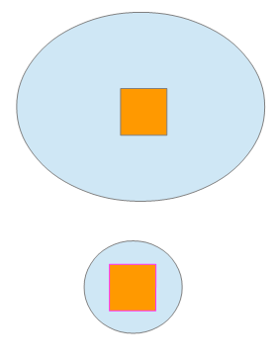Most people incorrectly perceive that the color of a small object changes when its surrounding context, like a circle changes its size
Popout | The ability of an item to automatically capture attention and be found among many distracting objects without conscious, sequential searching | 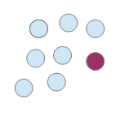It is very easy to spot a red circle among many blue circles because color hue has good popout.
Grouping | The ability of a channel to cause similar marks to be perceived as belonging together | Placing marks in the same spatial region  
- Practice assigning marks and channels to a dataset.

  - Find a dataset of interest with at least 1 categorical attribute and 3 quantitative attributes to be shown (theoretically) on one visualization.
    - Yes, these numbers are meant to challenge you a little…
    - Do not forget to include a link to where you located your dataset.
    - Your dataset should not already be visualized (or at least not in the way that you visualize it).
    - The actual fields in the dataset that you select to use are up to you.

  - Select mark(s) (point, line, shape, etc.)

  - Assign attributes to channels (i.e., vertical position, horizontal position, hue, length, width, etc.) keeping in mind the expressiveness and effectiveness principles discussed in the chapter (Recommend completing the reading first…)

  - Sketch out your visualization (you do not have visualize it with a tool unless you are ambitious) either by hand on in a simple drawing tool, realistic enough so you can evaluate it in next step.
    - Extra credit: Will be given if you create your designed visualization using a proper visualization tool (D3, tableau, etc.).

  - Evaluate your visualization based on expressiveness and effectiveness principles discussed in the chapter.

